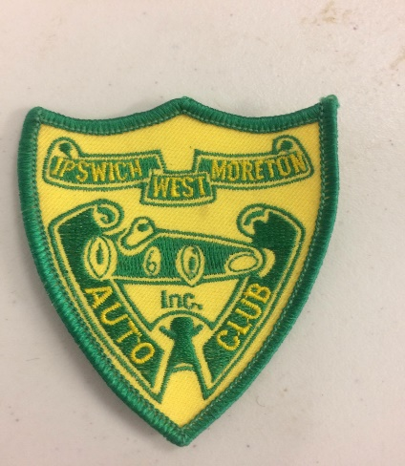
BULLETIN
PASSENGERS

The Come N Try day on Saturday 23rd February 2019
There are to be No Juniors with Juniors as passengers,
Only Adults with an open licence are permitted in the Passenger seats or Instructors with an open licence.

Stewards Clerk Of the Course

