Driving A VE Drift Ute on Dirt
So on the April Dirt Sprint I had an offer to drive Andrew Pearce’s Foxus XR5, but he was feeling crook and decided not to come out (fair enough). I was going out for timing anyway, and Kevin Parkes was bringing the usual Bond/Parkes N14 Pulsar Steed. But on arrival I saw Ken Luxton and we chatted and he offered a drive in son Gus’s VE Ute. Was an offer to hard to pass up, V8, manual, big wheel, sideways….
We lined up for the familiarisation lap, me driving, and first thing was that on taking off, I grabbed the closet thing to change gears….which was the very tall handbrake. Doh….so mental note, put hand on gear lever and check that you have the correct lever
Luckily, the torque means that you take off in 1st (or 2nd), shift to 3rd and just drive.
So the initial impression was that the car is well balanced, steers well. Not as quick steering as an Escort, but follows your command nicely. Oversteer is but a gentle nudge on the throttle at any time, but you can feed it in to try and get drive.
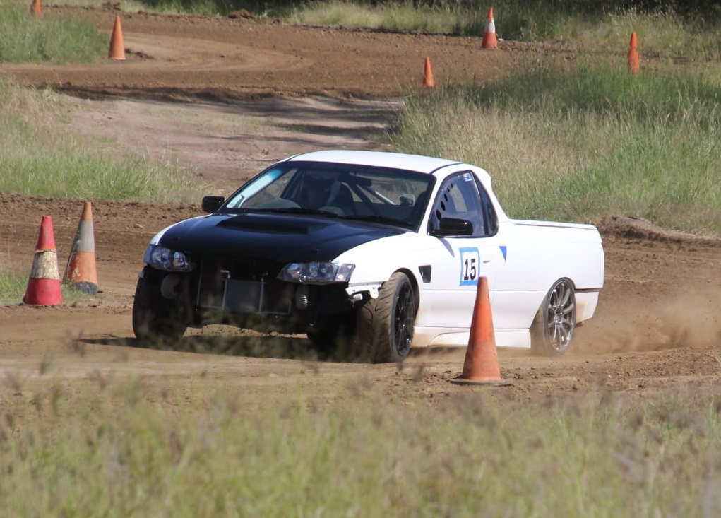
It wasn’t difficult to feel comfortable, although I felt the steering wheel was too close, so I had the seat back a bit, meaning clutch depression was hard. But it worked fine, and obviously for Gus it is all in the right position. Just not what I preferred. However, with the lack of gearchanges needed it was not an issue. If I drove it on bitumen for a longer time, it might have been harder for me. But again, not my car, and not bad, just different.
So off the pad in 2nd, and turn onto the track, accelerate an grab 3rd. Then into the sweeper and try to keep the power on, but in reality, a bit of feathering, and off/on at times (rather than a smooth gradual depression, which is the full race driver way). Then floor it to the left hander (if straight) and then brake hard and turn in, trying to keep the nose tight. Again floor it (as much as you can without endless wheelspin) and crest the little rise of the autocross track, and kink right towards Rad Guerin’s flagpoint. Now I must admit I like to give Rad a show, because he flags and we are competing, so in the early runs I often let it go very sideways and even a bit of a Scandinavian flick. Rad normally gives a thumbs up if you do good
So later runs saw cautious throttle to Rad, and heavy braking to the left, wide entry, before turning in and trying to ensure the nose is on the witches hats. If it doesn’t quite turn in, just blip the throttle, tail steps and voila, the nose is at the Hats:
The back straight is like a cautious exploration of grip, with the throttle slowly depressed until full grip is found, and on later runs, 100% through the kink (without going full sideways) before hard braking into the right.
Again, it is a balance of speed versus keeping the nose at the cones, to allow a good entry towards the flag point. If correct, it is tight on the right off the straight, and a good turn in to the left allows the car to be well left of the flaggies, so the right is opened up, allowing a good run to the last corner. Then it is brake, tip in, and if done well, small slide, power out and get 100% throttle near the finish line to start a new lap.
Overall impression – very balanced, good turn in, good braking, supple enough suspension (not as hard as I thought it would be) and great ability to throttle steer.
Was a really fun car to drive, and in reality not that hard to drive. I was trying pretty hard to get that 46, but it was still (kinda) under control. I would expect that most could get 9/10ths out of this car, noting that throttle control is key – don’t just floor it, and the last 1/10th takes full commitment:
Gus has built a really good car that was designed for drifting but works very well on a clay dirt surface also.
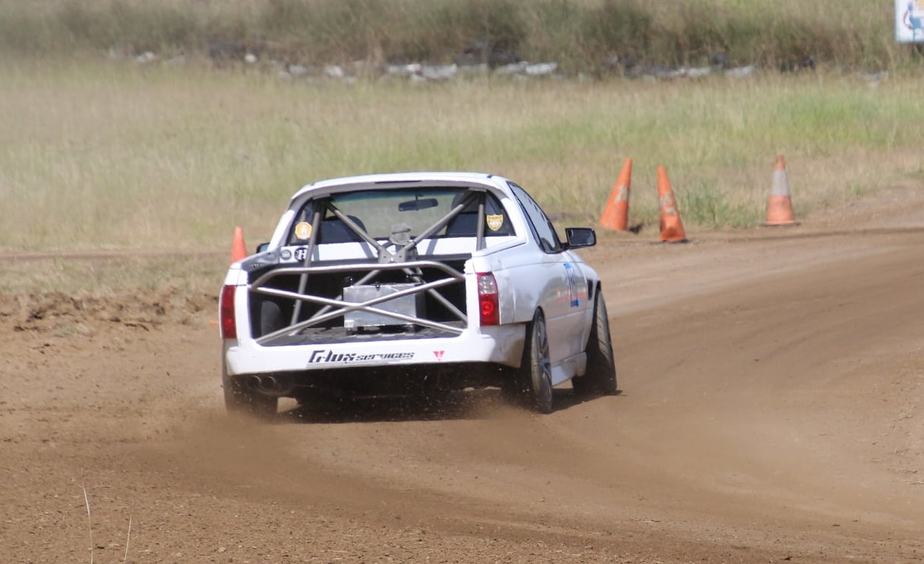
I am not sure, but I think this is Ken driving both photos

